OCR GCE A-Level

COMPUTER SCIENCE PROJECT

H446-03

Name : Benjamin Dyer

Candidate Number : <INSERT CANDIDATE NUMBER>

<Institution Name> : Doncaster UTC

Title of Project : Inventory management and library system

H446-03 – Project CONTENTS

Table of Contents

A. Analysis **Error! Bookmark not defined.**

B. Design 6

Systems diagram 6

C. Developing the coded solution (“The development story”) 7

D. Evaluation 7

Project Appendixes 8

# Analysis

## Introduction

Many industries with an inventory have an inventory management system to ensure that all equipment is properly managed, the most efficient way being done through digital technology, this can be done as a simple checklist or could have other features such as a recommendation section which requires a program which can demonstrate computational thinking. Most management systems are formed from a database which will need to be made for the program to analyse and input data into. For places of education such as colleges, these are needed for things such as student attendance and supplies or equipment as these things need to be monitored to make sure there is always the right equipment and that students are attending. It is much easier to have many users use a single program to take out equipment rather than all coming to a teacher as this wastes the time of both the students and the teachers and for a teacher time is important as they have many responsibilities and tasks.

## Research

From looking at many library systems, I have discovered that a recommendation system is key, this is as it allows people to find what would be more suitable to their use at a fast pace, this is a great display of computational thinking in which I hope to apply to my own work, in the case of recommending the most appropriate equipment for certain tasks. The way this basic AI will do this is through analysing a multitude if data to achieve the most accurate results, this is through the use of my SQL database as in this I will be adding many tables each with sectors that will make each item very unique in searching, there will be columns on categories such as: Available which will be set to True or False; Type which refers to the type of equipment that each piece of kit falls into, for example all lenses and tripods will fall under camera equipment; Accessories which will be in reference to any attachments or equipment that partners stock equipment, such as lenses, batteries, chargers etc. Moreover, each user will hopefully have their own table which will contain all the information on what equipment they have used, how long they have used it and when they last used it, this is as I want to add a procedure that can recommend equipment that is appropriate for their skill level, or if they haven’t used a piece of equipment much or haven’t used it in a certain length of time, then they will receive a video link to a tutorial video or they may have an online manual to help them out, for example there is a digital handbook to the Canon cameras.

Moreover, most items have a scannable mark to them, in the form of a QR or barcode, usually this is to save time as it is a quick process compared to manually typing an ID, which in itself comes with the risk of human error as they mistype the code which may be the code of another item, which may cause some confusion and mean that students may accidentally take the wrong equipment and possibly be accused for possibly stealing equipment

## Examples

This example is Snipe Asset Management, it has a lot of features and different sections for different logs and databases, as ana example they have one for what devices people have taken out and it goes into detail for what each item is and groups them for fast searching, and visually it is easy to understand which is great from an accessibility point of view. Moreover, there is one showing people’s subscriptions.

Cheqroom

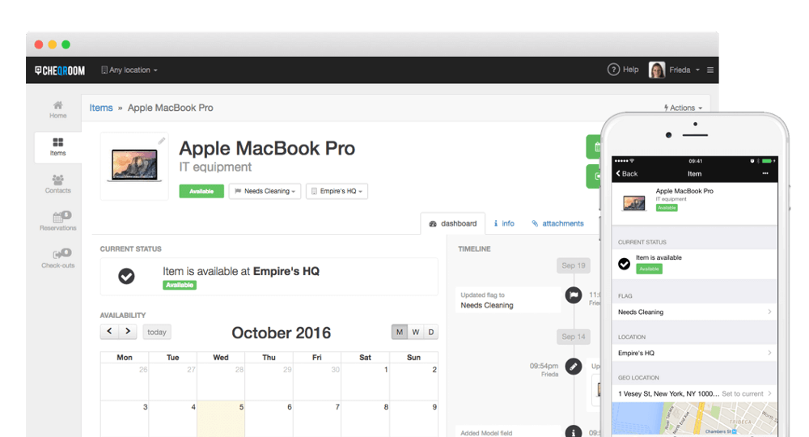

This is a very nice design which is very sleek and modernistic. It also carries many practical traits for example the calendar, a bold line of text at the top in a large font so it is clear to read what the product is, moreover it has a clear indication of whether it is available, and I like the inclusion of symbols and may carry this into my own personal app. Moreover, it has a mobile version to it so it is more accessible as it is available cross platform. From this I think it is important I make

+1 more

Justifying your approach

## Stakeholders

For this project my main stakeholder is Miss Allen (Head of Department for Digital Media) from Doncaster UTC, a new college to appear in Doncaster. Doncaster UTC has gained quite the reputation for being a great place to study Engineering, Digital Media and from September 2021, Medical Science as students get a unique learning experience which is a combination of knowledge and application, practical skills, and employer engagement. From this style of education, departments such as Digital Media have a large inventory of equipment, with most of it being high end in terms of value. This means it is important that the equipment is properly maintained and cared for, so no damage should be done to it nor should any of it get lost, this applies to all accessories to equipment, in the case of media this is things such as lens caps, chargers and sliders.

* Meeting their needs

Moreover, the students that will be using this app are counted as stakeholders, they will be post 16 students ages 16-18 and may not have the most experience with technology such as the cameras and VR. However, as they will be taking technology-oriented subjects such as Digital Media, ICT and Computer Science, they should be able to navigate most apps and basic software. Moreover, to make the most of their time at Doncaster UTC and their studies, they will be using equipment both inside and outside the classroom. As they may not have the full understanding of the equipment, they may not be fully equipped for some tasks such as filming in certain locations, so they may need advice from a teacher or a more experienced student.

## Problem

The problem that I will be facing is that the media department is lacking in an inventory management system, and that students are not fully capable of keeping track of what equipment they have taken home, or they do not know what equipment is needed or how to use it. From this a multitude of potential issues including equipment being lost, the wrong equipment being taken out, equipment getting damaged and students not correctly knowing how to use equipment. As this equipment is very valuable and high in price, the UTC cannot afford of have any of these potential issues to occur as it can inhibit learning for the students and could lead to other investments from the college to be put on hold in order to deal with that issue. Moreover, as students aren’t very experienced with equipment, it is important that there is some way to teach them how to use the piece of equipment and give advice, like a teacher or specialist would. Moreover, some students who are taking out equipment do not notify the teacher whether the equipment has been brought back, so the teacher may not be aware of where it is and may confront a student about them.

## Features of the proposed solution

My proposed solution is to make a pc application which acts as an inventory management system for media, it will use **colour coded QR codes to act as links to items within the database**, each one being obviously linked to a specific piece of equipment in case of multiple pieces of the same equipment, each selection being made will give a clear indication of all components included, them being attachments, chargers, storage, or accessories. Moreover, I will **be constructing an SQL database** which will store each piece of equipment and give them values and properties which will allow me to **recommend the users pieces of equipment** based on tasks, environments and previous uses, this will improve the experience for users as it will help their use.

If the user is using a new piece of equipment, there will be **an algorithm in place which will automatically send the user sources in order to help them operate the equipment**. In case of the event that students are not able to scan the barcode, a unique tag will be on the card with the barcode on, I will most likely have either in the form of XXXX-XXXX-XXXX-XXXX or XX XXXX XXXX depending on how much equipment is going to be in the inventory, an embedded video will be included to show users how to use the website and that will be stored in the help section of the website.

For my first idea I was going to use a SQL database made in Microsoft Access, however I realised that this would take too long and be too complicated to run alongside Python so I will be creating a CSV file instead as I will be able to easily read, write and remove data from it. With it I will have multiple CSV files, one each for equipment and people, then one showing what is currently in use. I would ensure that this document is constantly being refreshed to make sure that there is not too many in there, instead as a log I would keep a separate document to be able to track past activities in case the information is needed. I will also try implement a feature which will remove items from either CSV file as I want to ensure there is no redundancy within my files as all it will do is gradually increase the file size making it slower.

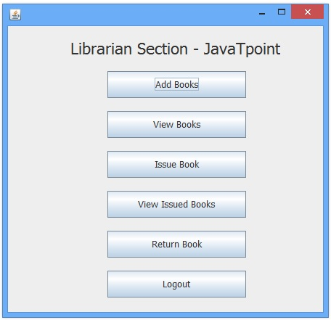

Moreover, later plans and renditions will be used to accommodate different disabilities, such as a colour-blind mode for users, a possible text to voice feature and an easy-to-read mode so that it is easy for users to operate and navigate whilst not inhibiting any of its functionality. I also believe there should be some form of communication to teachers, whether that means a form of hyperlink to outlook so that they can email teachers, or if it is to add some form of chat system however, I believe that this isn’t a necessity so would be part of an update installation in later versions to this app.

In addition, as staff members are also going to be in use of this app, they will have a similar version of the app however with features that would be restricted to the students, this includes a section to monitor who is using what equipment and for how long. This is useful information for staff to know as equipment must be tracked constantly.

The app will need to be able to easily read and write into my data storage, this will be composed of 4 separate CSV files each with their own purpose and I will ensure each has an update feature, this will be either in the form of manual updates or scheduled auto-updates. This is to ensure my information is all up to date and correct as my app will have to be doing checks and comparisons between data that has been used in my python program and the ones in my data storage.

There is going to be a login system which will need a procedure which compares information inputted into the interface with the one stored onto the text document, this will be a form of verification of their identity.

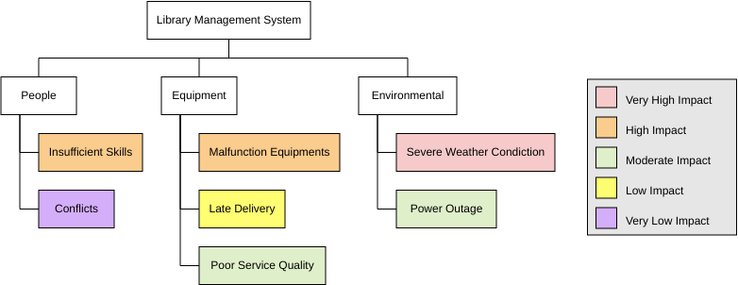

I will be making the software in Python with the addition of tkinter, then I will be doing the most of my testing on the pc itself at college. All my data will be stored as a CSV file as a text document. I will be doing a lot of my planning in Adobe Photoshop and Adobe XD, this will be done to produce wireframes and the visualisation diagrams of the pages in my application, I may also need to plan out some pseudocode or produce a site map to demonstrate how the navigation will work

## Hardware/software Requirements

In terms of hardware, there is a need for a device with a camera to be able to scan the barcodes so that the information may then be sent to the pc app. This will also mean in terms of hardware, there must be some form of server that is to store the databases, most likely it will connect to the computers via a wireless network, I may consider looking to see if any are available through Wi-Fi, and that if it can work with cloud saved databases.

For the accessibility of my product, even though I am aware that most of the users can use and navigating through basic apps, I must treat the matter with the idea that no one can, this will mean that I will avoid all shortcuts and make sure everything is clear and labelled. Moreover, I will make sure that there is easy to read text for people with difficulties seeing or reading large bodies of text. Perhaps if I have enough time, I will conduct research into colour-blind modes so I can accommodate those needs, I feel it important that everyone has the same experience when using the app.

Moreover, like Snipe, I will need an online server to run the software to make it compatible across multiple devices as well as to make it compatible with windows as well as Mac and Linux, for this I will make sure the code is useable across all these operating systems.

## Success criteria

* Will have an easy to navigate system with clearly labelled buttons as people can have varied abilities and understanding of applications and it isn’t suitable to approach this in belief that all users are the same in ability, also there is potential for people to have certain disabilities which could inhibit their ability to navigate the site.
* Will allow students, teachers, and admin to log in and out of the system as people will be using the app for different reasons, for example the admin will want to run maintenance on the system
* Will allow students to take out equipment, this is the main reason for this apps existence as it is to track equipment being taken in and out
* Will be able to track people’s usage of equipment and be able to offer support where needed because a teacher won’t be able to help many students and they are limited in knowledge on equipment and may have to source out information on the internet themselves
* Will notify teachers of when a student is taking out equipment or hasn’t returned the equipment in time so that they can deal with equipment, and it allows them to check if the equipment has been brought in
* Will notify students on when it is the day you need to return the equipment to ensure that they are bringing the equipment in on time and won’t be sanctioned for bringing it in late
* Will allow students to request an extension on their usage of equipment as it is expected that some students may underestimate how long they will need a piece of equipment
* Will have a bottleneck system to ensure a student can only take out a certain amount of equipment at once
* Will allow teachers/admin to add to the equipment inventory from their accounts
* Will allow admin to manage accounts to be able to add accounts and remove them

## Limitations

The main limitations for this project are as follows:

* Time – I am under a limited amount of time so may not have the ability to implement all features to maximise accessibility and add on other features
* Skill – As I will be doing types of coding I’ve never done before, I will have to do a lot of research and may make mistakes in my code, this could mean that some features don’t fully function
* Hardware – with some computers, having software which repeatedly refreshes could be extensive on the CPU and may cause the application to run slower than expected
* Server – this is going to be needed to update regularly so there is going to be a server that’s consistently running, whether that is a physical server or an online one in which both will require some form of funding
* It is going to be menu based and isn’t going to have many images in there to preserve running speeds

## Why it needs to be solved by a computer

Computers are better at storing information than humans, this is because they can organise them easily into documents that it can easily access, moreover you aren’t limited with how much you can write onto documents compared to filling out a sheet. Moreover, you can back up any files to the internet through One Drive, this will mean that if for some reason the file is lost it can be recovered. Moreover, due to having access to Web 3.0, we have more information available to us through technology. In addition, a college is limited in it number of staff, so a teacher will only be able to help out a single student, whereas an app is used by multiple people so is more suitable to have a source of help and information on the app and have the teacher there to provide additional support.

Computers are great when needing to problem solve, for example there is limited supply of equipment to supply all students, so it will be able to recognise if a student is needing any equipment currently not in stock and be able to recommend a suitable alternative which will still allow the student to perform a task to a suitable and similar degree of quality.

It will also be able to perform data mining on students and track how much they know and how well they can use pieces of equipment, and it will be able to track and support people based on the amount of experience they have with equipment.

## Discussion with client/target user

After a discussion with Miss Allen I could see that I clearly needed to adjust my app to be for mostly people of a lower skill range however I also will accommodate it for higher skilled users so that it is appealing to all

# B. Design

<See H446-03 Project Advice Booklet for help and guidance of what must go here.>

## Systems diagram

Site map 1 -

This design was okay but required that I use SQL as my database which would have worked but would have made my application more slow when in partnership with my database as the computer would be having to run 2 software simultaneously, so instead I’m going to be utilising CSV within Python as instead of making a full database, all information that would be stored in a database would be read and written onto a text file

Image will be of students using media equipment

This is a basic visual for the login screen of my application, it will be clear and easy to read and will be the interface for both teachers and users, it will appear very simple in its design so that it isn’t difficult for people to read and also will be appealing and welcoming to users.

This is showing the area where people will begin selecting the equipment they want; I will probably add further buttons if needs be for example possibly adding in a logout feature for people who are mid-way through avigation. I also will add a search bar as well as a scroll down menu, this will help improve useability for people and make searching faster.

This is where a student has clicked on an item to add to cart, this will be a page where people can look into what is available and it will tell users what the equipment is used for and this will be the sector where the recommendation system works in as it will recommend resources to help based on the individuals skill level, the recommended sources will be based on the persons role and skill and how often they use the equipment.

This is the page which the user will see their cart and then checkout all of the equipment, I will also add a feature where they will add their return date, then once done the submit button will then log them out, I may add a feature where they can only do 3 checkout sessions at a time and they can also take out a certain number of items. It will also add a recommendation for additional equipment that the person may have for example if they do not have lighting equipment then it will recommend lighting equipment.

systems diagram –

## Pseudocode

First, I will be trying to breakdown the login system

FileName = “Login.txt”

With open(FileName) as F_Obj:

import tkinter

from tkinter import *

import tkinter.font as font

import tkinter.messagebox

def messageCall():

    tkinter.messagebox.showinfo("hello world", "hello world")

screen = tkinter.Tk()

myfont = font.Font(family = 'american typewriter') #creates a font variable to be used

screen.geometry("250x250") #window size

screen.title("window title") #window title

b = tkinter.Button(screen, text="Click here", font = myfont, bd = 7, fg = 'blue', activeforeground = 'red', height = 2, command = messageCall) #creates a button variable

b.place(relx = 0.5, rely = 0.5, anchor = CENTER) #places the button variable

screen.mainloop() #required to start instructions

This is a basic program showing how to program a TKinter file into making the window for my system, it shows a button and demonstrates what happens when you make and press a button, this will be the base for my work to encapsulate the main code.

# Developing the coded solution (“The development story”)

This needs to be moved into a different position

<See H446-03 Project Advice Booklet for help and guidance of what must go here.>

# D. Evaluation

<See H446-03 Project Advice Booklet for help and guidance of what must go here.>

# Project Appendixes

Insert as many project appendixes as you need for your project.

These might include, but are not limited to:

* Complete Code Listing (ESSENTIAL)
* Interview Transcripts
* Meeting notes
* Observation notes or questionnaires

# Bibliography

|  |  |
| --- | --- |
| **Author** | Real Python |
| **Article title:** | Python GUI Programming With Tkinter – Real Python |
| **Website title:** | Realpython.com |
| **URL:** | https://realpython.com/python-gui-tkinter/ |